ITC 4214 Midterm Report
Athanasios Ktenas
Professor Leonardos Mageiros

Contents
Overview 3
Task Allocation System 3
Coding Decisions 3
Tasks Booking Steps Process Bar 3
Mobile View Booking Steps 4
Navbar & Footer Injected as Components 4
Cleanup Using Regular Expressions 4
Github Version Control 5
Lighthouse Report 5
Desktop Mode 6
Mobile Mode 7
Reflection and challenges 8
Imagery 8

Overview
For the midterm project I have created the front end code of a thematic website using the programming languages HTML, CSS and Javascript. The C4 Tattoo studio page supports a booking process, client review system, contact form and a news box featuring API integration. For the correct display of the website, it is required that the live server extension on Visual Studio Code is used.

Task Allocation System
The task system has been configured into a booking process. The first step of the process is selecting the service that the client would like to receive from the shop, such as tattoos or any piercing type provided. Then, the client is asked to select an artist. After selecting the artist, the available time slots are displayed. Lastly the booking summary is shown so that the client can verify that all their inputs are correct.
The booking process has been designed in the same HTML page, using CSS and Javascript to hide or reveal elements. In the HTML file, every step has been given an ID. The app.js script finds which step is active and modifies the CSS classes by using the renderStep function. Each step’s containers that should not be shown are given a “d-none” class so only the current booking step’s containers are displayed to the user.
Lastly, the user can simply click the “BACK” button on the top left of the booking page to return to the previous step of the booking process. This is done by using the following function:
$(document).on('click', '#booking-back-btn', function(e)
The click event object (e) is given as input to the callback function, so that the back button clicked does not redirect the user to the home page again. Javascript intercepts the default event of the back button and instead reduces the current step by one. As a result, the client is successfully transported to the previous step.

Coding Decisions

Tasks Booking Steps Process Bar
The tasks.html file contains the html code for the booking page. This page has been designed in a step by step model in order to finally book the appointment. The process steps are shown in the top of the page in a container that displays: “category > service > artist > time > confirm”. The arrows are shown in each step of the process except the last one. This is done by using a pseudo-element in the styles.css file which adds an “>” symbol at the end of each step as long as it is not the last child of the HTML booking container. The CSS code looks like this:
.booking-progress-step:not(:last-child)::after {
Booking-progress-step is the HTML parent category and CSS essentially appends the arrow character at the end of each child’s content AS LONG AS it is not the last child of the category. A pseudo element in CSS allows for the creation of elements without them being part of the HTML code. Specifically, pseudo elements target the parts inside an HTML element, which in this case is the booking-progress-step box inside text. The “::” used in the code targets the text inside the box and injects the arrow after it. The way CSS knows where to place the arrow is by using the “::after” which injects content at the end of an element. On the other hand, the “:” acts as a condition. In this part of the code, “:not(:last-child)”, a condition is set. CSS selects the HTML category containing the progress steps and appends an arrow in the end of its content, ONLY IF it is NOT the LAST CHILD of this category.
The reason why this line of code is designed in a clever manner is because new steps can be added and CSS will know exactly where to place the step arrows and where not to.

Mobile View Booking Steps
Responsive design is supported by limiting the mobile view of the step bar to only current and next step. This is done by the following CSS code:
.booking-progress-step.is-active + .booking-progress-step {
This line of code combines CSS and Javascript. On the first part, the browser finds the user’s current step in the process. If it is “TIME”, CSS knows that this is the current step from the “.is-active” Javascript function. The “+” is the most essential part of the code as it selects the neighboring element of the current active step, which is of course the next one. As a result, the mobile user sees only the current and next step on the top of his screen providing responsive design in a smart way.

Navbar & Footer Injected as Components
In the Javascript file, the navigation bar and footer are injected into each part of the shop as components. This is very important and clever as performing changes in the “navbar.html” file will update the navbar in the home, booking, reviews, about and contact pages.
This is done by the two following functions:
function loadFooter() {
function loadNavbar() {
Both use jquery query selectors which searches the ID in the html and injects the component.

Cleanup Using Regular Expressions
In order to clean up the markdown mode data returned by the Jina AI API fetch, regular expression cleanup has been used. The following function cleans up the raw markdown mode text from all the symbols:
function cleanMarkdownText(text) {
return text.replace(/[#*_`[\]()]/g, '').trim().replace(/\s+/g, ' ');
}
This compact function works in three parts. The first one is:
.replace(/[#*_`[\]()]/g, '')
The replace part followed by the symbols in the two “/ /” will be replaced with an empty space ‘ ‘. The letter g before the coma instructs replace to read the whole line and not just stop at the first character it found. The following two parts:
.trim().replace(/\s+/g, ' ');
By using .trim, any extra spaces at the start and the end of the lines are removed and the replace function is used again, but this time to condense multiple spaces into one.

Github Version Control
The following github repository has been created for version control of this website.
https://github.com/aktenas/C4-Tattoo

Lighthouse Report
The built in chrome lighthouse developer tool is an auditing tool which tests a website in terms of performance, accessibility and search engine optimization. On the booking page, C4 Tattoo scored the following results:
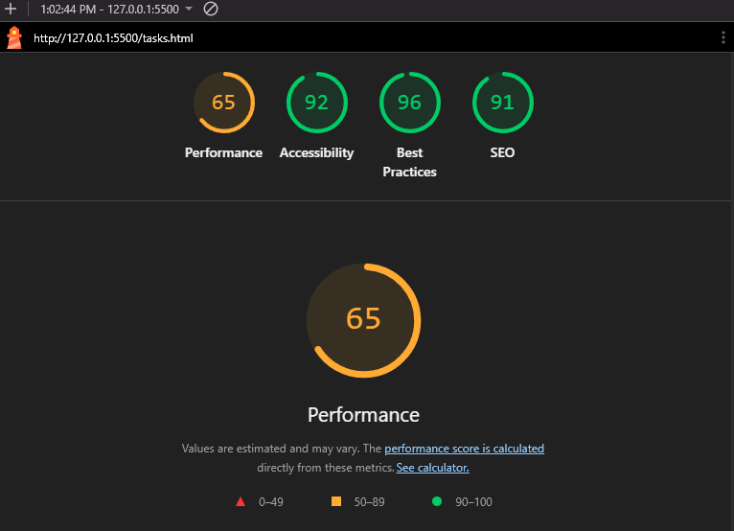
The 65% on the performance is mainly due to the heavy use of images, CSS and fonts load. However a 92% on accessibility is very satisfying, as it means that the website is designed to be used by blind people. All images have alt attributes, providing a meaningful description to people who don’t have the ability to see. For a tattoo and piercing shop this is essential as images are described by the narrator, and right below the description of the piercing is written.
This test was ran on mobile mode, meaning that on mobile devices this website provides amazing accessibility results and responsive design.

Desktop Mode
The tests for all the pages on desktop mode have also been executed.
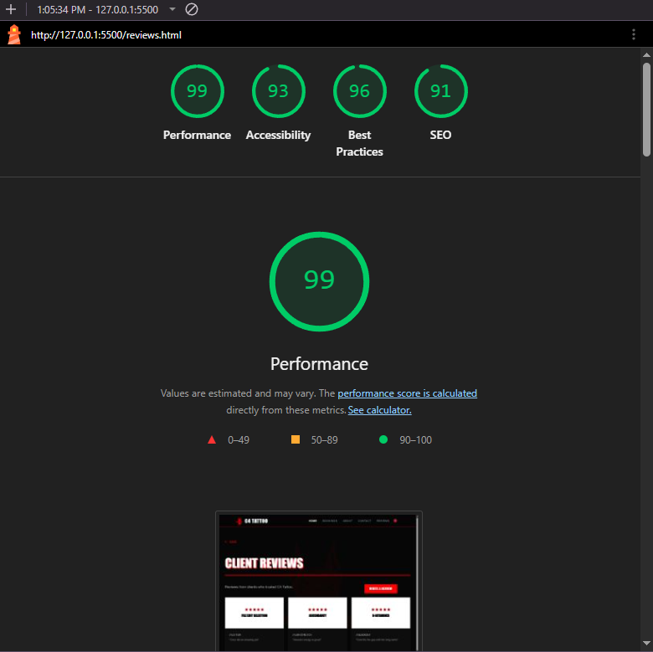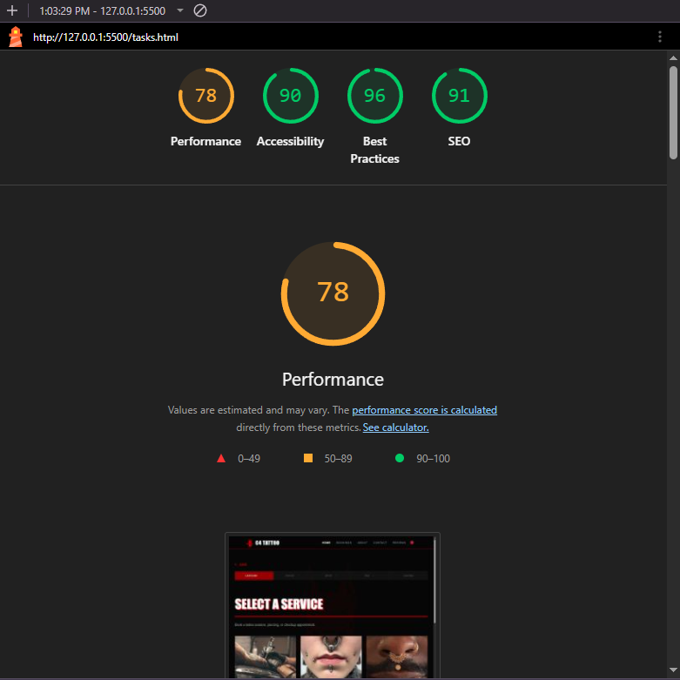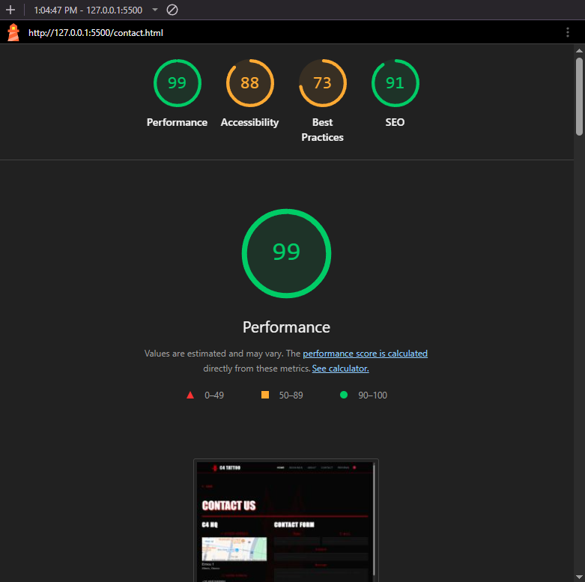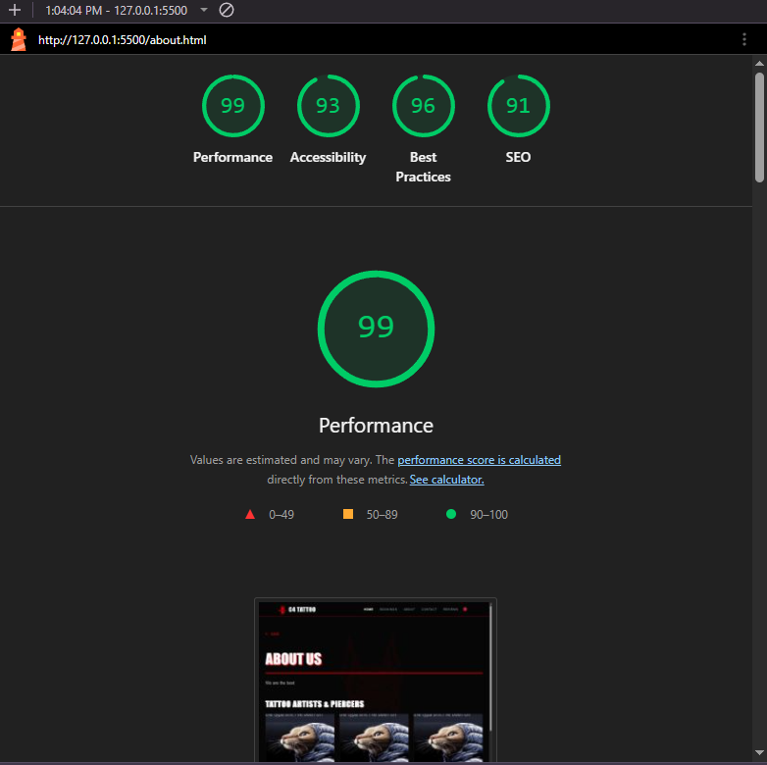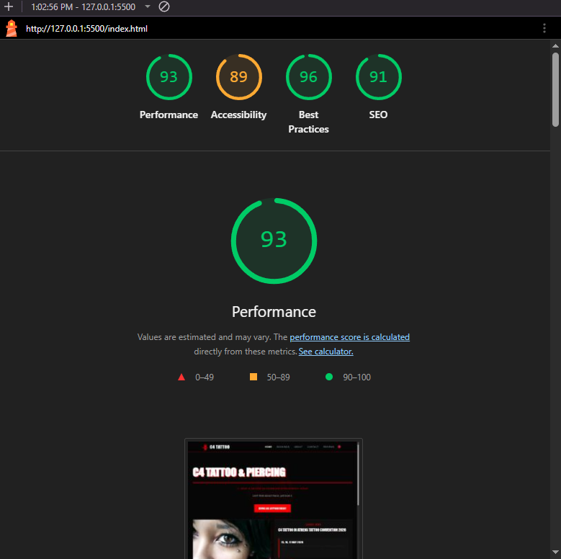

Mobile Mode
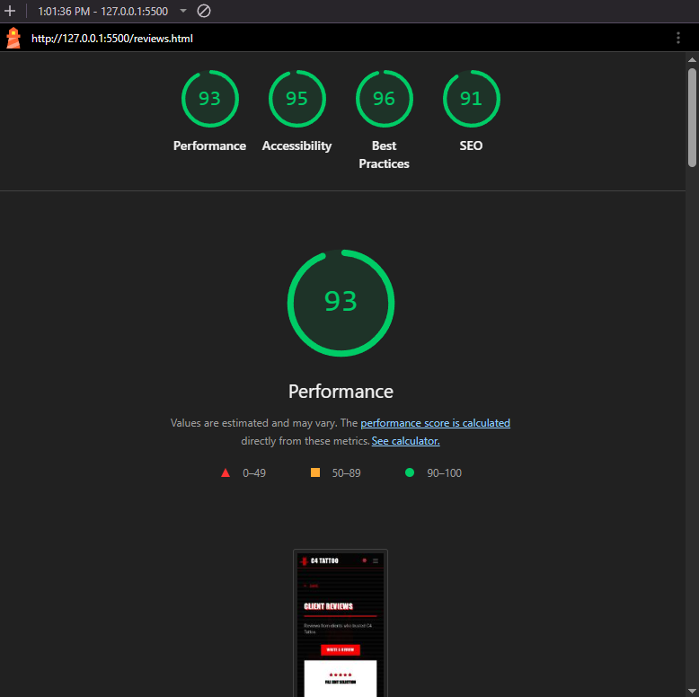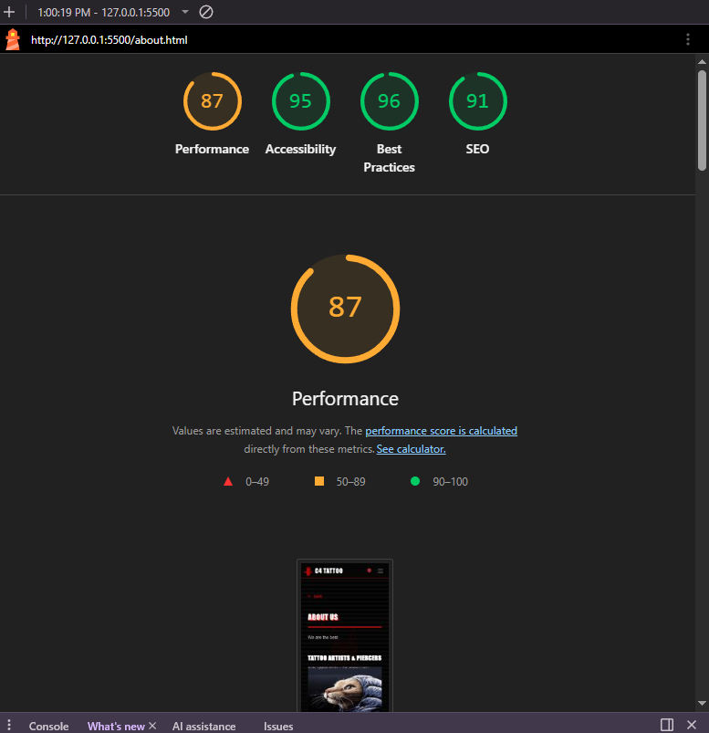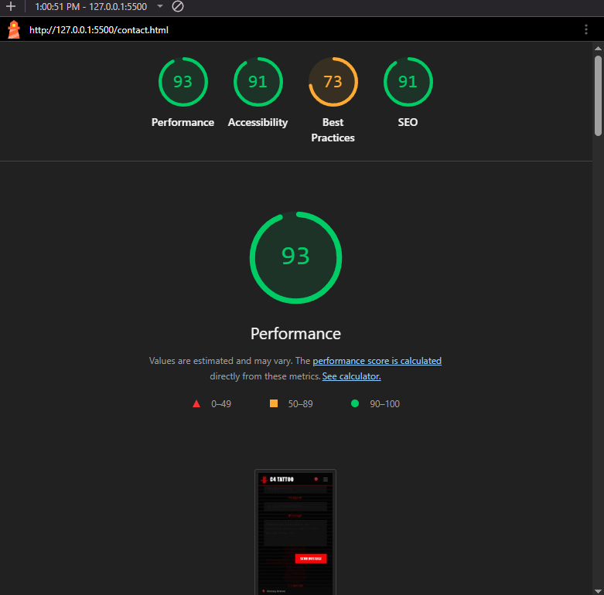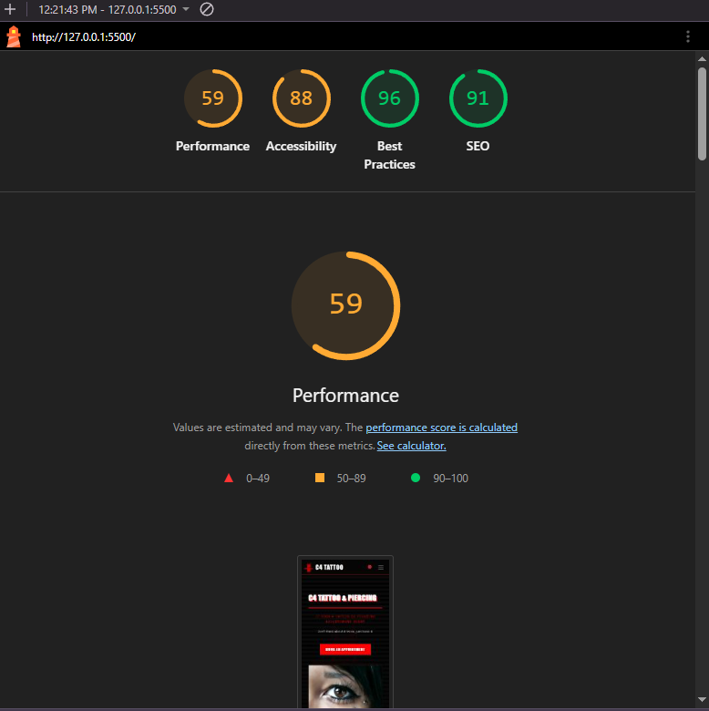

Reflection and challenges
One of the challenges faced was fetching the news from the Athens Tattoo Convention website and presenting it in the index.html file in the appropriate container. At first the allOrigins proxy was used however it gave bad gateway errors later on so the method of fetching was switched to the jina.ai API.
Another issue is that by opening the index.html file the navigation bar and footer do not appear even though the app.js code is supposed to inject them. This happens due to a browser protection mechanism called Cross Origin Resource Sharing. What this mechanism does is identify the origins based on protocol, domain and port and run a security check on whether the resources should be exchanged. In this case the files index.html and navbar.html are treated as unique origins as they are not hosted in a webserver, thus there cannot be sent any “Access Control Allow Origin” header which allows the index.html to access the navbar component and the javascript code to inject it successfully.
To avoid this issue, the code has to be hosted in a webserver, or by just using the VScode live server extension. This way CORS identifies that both files originate from http://127.0.0.1:5500 and the javascript code can fetch the navigation bar and footer components.

Imagery
The piercing images in the service step of the booking process are sourced from the Uncle Chronis Tattoo website, by which the C4 website has been heavily inspired. The images have been modified in photoshop to give the piercings a red accent instead of yellow.
Other images in the carousel, artists and latest news have been sourced from the web. The logo was partially created by me in photoshop by modifying an image from the web. No AI has been used for the imagery of this website.

